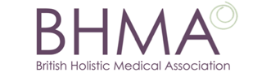

The BHMA Student Essay Prize – £250

Closing date: Thursday, 31st March 2016

For the tenth year, the British Holistic Medical Association prize of £250 will be awarded to the undergraduate healthcare or medical student who submits the best 1,500-word essay on the following topic:

Diagnosis: Are we medicalising human experience? A radical review

We would like you to use this essay to radically and critically consider the implications of medical diagnosis on people’s lives. Examples to illustrate your arguments would be beneficial.

This is a good opportunity to enhance your CV. The winning essay will be published in the Journal of Holistic Healthcare and the top three entries on our website.

Please submit your essay with your name, address, email, university or college, course attending and year of study, and send by e-mail to:

suhillrise@btinternet.com

www.bhma.org

