The importance of holism in medical care today and ways this can be promoted

By Vishnu Parameshwaran, Oxford University

“The whole is ‘other’ than the sum of its parts”
- Kurt Koffka

Holistic medicine advocates a gestalt conceptualisation of the patient, such that the evaluation of the patient as a whole is considered to be better than approaching the patient purely in symptomatic or scientific terms. In “treating the whole person rather than just the physical symptoms of a disease”, practitioners of holistic medicine advocate a view of both patient and patient-experienced disease as entities composed not just of entirely biophysical properties, but of interwoven psychological, experiential and social dimensions. As such, the practice of holistic medicine implies that to only consider a patient and their illness in biophysical terms is to fundamentally neglect integral components of both the patient’s illness and the patient’s experience of that illness. Holistic medicine resists the discussion of disease in generalised abstract terms as it presents a paradigm of understanding in which the experience of illness by person A in their individualised context is never identical to the experience of the same illness by person B. This essay will argue that holistic medicine is important in medical care today because there is a demand from patients for a holistic approach from their clinicians and because there exists a growing body of evidence that suggests optimising a patient’s multidimensional quality of life can improve their physical outcomes. This essay will then go on to propose practical ways of promoting holism, from engendering a holistic approach to medicine at the beginning of a clinician’s career in medical school, to the advocacy and provision of instruments for holistic assessment later on in a practising clinician’s career.

Holism is important in medical care today because patients want it and because it improves health outcomes

The paradigm of medicine in which the paternalistic clinician acts didactically and in which the patient acts as a passive recipient of healthcare is both outdated and ineffective. Whilst there exists general treatment protocols for the management of certain conditions such as asthma and diabetes, disease management has progressed to a patient-centred process in which the impetus is on the physician to collaborate with the patient to provide evidence-based information that is utilised by the patient to make a tailored informed decision. The decision-making process is informed not just by the scientific evidence base for a particular course of action, but by the pre-held values and cognitions held by the patient, as well as by motivations from their social context. A holistic approach is important because there is a demand from patients that their clinician collaborates with them in an individualistic way that acknowledges this complexity of decision-making and provides an authentic sense of patient-centred care,.

Using a meta-ethnographic method, Franzel et al, 2013 systematically reviewed 30 studies to elucidate the motivations for patients undertaking complementary medicine. The review found that the single most common motivational theme was a desire for holism, a desire for “an individual approach to be seen as a whole person”, as opposed to being viewed as singular accounts of symptoms and biomedical features. Other motivations for seeking out complementary therapies (as seen in figure 1) included a desire for “personal growth” induced by the healthcare encounter, “integrative care” of unique treatments personally tailored to them, and “emotional disease handling” in which the practitioner gives the patient the space and support to emotionally interpret the disease.

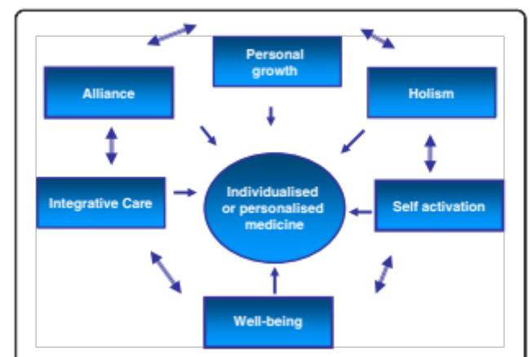

Figure 1 from Franzel et al 2013 illustrates the motivations that guide patients' understanding of individualised medicine

A potential challenge to holism is whether it is feasible to provide an assessment of all the facets of a person when dealing with large caseloads, limited time and other challenging commitments. However there exists a growing body of evidence that suggests optimising a patient’s quality of life beyond purely biomedical terms can improve their biomedical outcomes. Patients with cardiovascular disease and cancer whose management strategies incorporated an optimisation of quality of life have been shown to live for longer, as well as report fewer symptoms. The implication of these findings is that treatment plans that do not cater beyond the purely biomedical do not fully maximise health outcomes.

This has been reiterated in research detailing elderly patients’ experiences in emergency care in which the immediate and future preventative needs of patients could only be met via an integrated approach that addressed the initial medical presentation as well as the functional, social, emotional and spiritual status of the patient,. Crawford et al, 2013 in their biopsychosocial analysis of controlled positive airway pressure adherence explain that although identifying individual biopsychosocial profiles is time and labour intensive, holistic analysis in the long run improves adherence thereby saving valuable fiscal resources.

Therefore it is clear that holistic medicine in clinical practice is of the highest importance because when a clinician fails to be holistic in their analysis of an individual patient, patients receive neither the best care nor the care they desire.

Promoting holism

Two practical strategies for promoting holism are the targeted raising of awareness of the holistic approach to medical students and the utilisation of holistic assessment tools in clinical practice.

Promoting holistic medicine by targeting the curriculum at medical schools alludes to the notion that holistic thinking is a paradigm of thought that should be fostered from the beginning of a clinician’s career and applied to their future practice. Clinical teachers should frame clinical teaching with an emphasis on Engel’s biopsychosocial model of disease, such that medical students are taught to think about the multifaceted components of disease from the offset. Teaching a conceptualisation of how to approach patients lacks the explicit clarity that teaching topics such as asthma management protocols offers. However medical students could receive meaningful feedback from clinicians on their holistic approach via a variety of methods.

Firstly through the setting up of a journal competition that encourages students to submit extended case reports on a patient they have seen. Accepted submissions would be those where the student has thought reflectively and holistically about how that particular patient has experienced a disease, with the most successful commenting as fully on how the different dimensions of a patient affects their experience of the disease. Secondly during ward-based teaching supervising clinicians could employ methods such as inviting students to take holistic histories from two patients with the same diagnosis and present how a holistic understanding of medicine has affected the different management and outcomes of the two patients. Thirdly the incorporation of a holistic history station in clinical exams, or alternatively the incorporation of holistic thinking into the mark scheme for clinical exams, would be a further method of fostering holism in future doctors from the offset. Berge et al, 2013 reported the explication of a holistic teaching program on the dentistry course at the University of Bergen in Norway, which demonstrates that this method is feasible in medical education.

The second broad strategy for the promotion of holism is the utilisation by clinicians of assessment instruments that facilitate a holistic approach to patients in their daily praxis. Medical practitioners occupy a privileged position in their leadership role of the multidisciplinary team. The privilege of this position could be utilised to disseminate a holistic approach throughout the clinical team. To illustrate this with Parkinson’s disease, Martinez-Martin et al, 2013 proposed that there exists a variety of qualitative assessment tools, such as the Hoehn and Yahr staging assessment and the Non-Motor Symptoms Questionnaire, that serve as useful indicators of patient-reported outcomes such as treatment effectiveness and disease activity. Martinez-Martin demonstrated that the utilisation of patient-reported assessments (as shown in figure 2) helped clinicians to work towards an individualised holistic patient care. By encouraging the use of assessment tools such as these, clinicians can promote individualised patient-reported holism through their clinical practice.
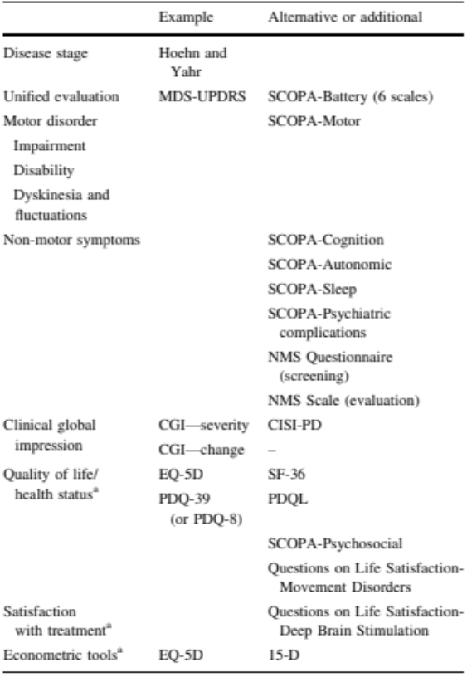

Figure 2 from Martinez-Martin demonstrates the assessment tools clinicians can utilise to translate holistic thought into the assessment of Parkinson's disease

A second example of promoting holism via holistic assessment in clinical practice was outlined by Tempest et al, 2013, who observed that in an acute stroke multidisciplinary team the implementation of the International
Classification of Functioning, Disability and Health (a contextual classification system for disability) helped promote holistic thinking amongst the team by prompting the health professionals to consider both context and function; one clinician stated “it makes you…aware of all the different aspects that are affected”. A top down advocacy of the use of formal holistic assessment tools employed by advocates of the holistic method promotes holistic medicine within the health system via dissemination and praxis.

Conclusion

The importance of approaching patients in a holistic manner as healthcare professionals today cannot be understated. Qualitative research has emphasised that there is a desire from patients for holistic individualised treatment, and such management strategies have been shown to improve health outcomes and treatment adherence. Thus by fostering the importance of holism in medical students and by utilising the roles of clinical practitioners to make holistic assessment tools integral to patient care, it is possible for individualised holistic medicine to fast become the default model of understanding and managing the patient-disease experience.

Bibliography

? Wong B (2010). Gestalt principles (Part 1). Nat Methods 7(11): 863
Concise Oxford English Dictionary, Oxford University Press, 2008
British Thoracic Society (2012), British Guideline on the Management of Asthma, http://www.brit-thoracic.org.uk/Portals/0/Guidelines/AsthmaGuidelines/sign101%20Jan%202012.pdf
The National Collaborating Centre for Chronic Conditions (2002), NICE, Type 2 Diabetes – National clinical guideline for management in primary and secondary care (update), http://www.nice.org.uk/nicemedia/live/11983/40803/40803.pdf
Haynes RB, Devereaux PJ, Guyatt GH (2002). Physicians’ and patients’ choices in evidence based practice. BMJ 324(7350): 1350
Verhoef MJ, Balneaves LG, Boon HS, Vroegindewey A (2005). Reasons for and characteristics associated with complementary and alternative medicine use among adult cancer patients: a systematic review. Integr Cancer Ther 4(4): 274-286
Ernst E, Hung SK (2011). Great Expectations. Patient 4: 89-101
Franzel B, Schwiegershausen M, Heusser P, Berger B (2013). Individualised medicine from the perspectives of patients using complementary therapies: a meta-ethnography approach. BMC Complement Altern Med 3:13: 124
Richardson J (2004). What patients expect from complementary therapy: a qualitative study. Am J Public Health 94(6): 1049-1053
Ornish D, Brown SE, Scherwitz LW, Billings JH, Armstrong WR, Ports TA, Kirkeeide RL, Brand RJ, Gould KL (1990). Can lifestyle changes reverse coronary heart disease? The Lifestyle Heart Trial. Lancet 336(8708): 129-133
Spiegel D, Bloom JR, Kraemer HC, Gottheil E (1989). Effect of psychosocial treatment on survival of patients with metastatic breast cancer. Lancet 2(8668): 888-891
Ventegodt S, Merrick J, Andersen NJ (2003). Quality of life as medicine: a pilot study of patients with chronic illness and pain. TheScientificWorldJOURNAL 3: 520-532
Frank C, Asp M, Dahlberg K (2009). Patient participation in emergency care – a phenomenographic study based on patients’ lived experience. Int Emerg Nurs 17(1): 15-22
Olive P (2003). The holistic nursing care of patients with minor injuries attending the A&E department. Accid Emerg Nurs 11(1): 27-32
Crawford MR, Espie CA, Bartlett DJ, Grunstein RR (2013). Integrating psychology and medicine in CPAP adherence – New concepts? Sleep Med Rev S1087-0792(13): 000029-4 [Epub ahead of print]
Engel G (1977). The need for a new medical model: a challenge for biomedicine. Science 196: 129-36
Berge ME, Berg E, Ingebrigtsen J (2013). A critical appraisal of holistic teaching, and its effects on dental student learning at University of Bergen, Norway. J Dent Educ 77(5): 612-20
Martinez-Martin P (2013). Instruments for holistic assessment of Parkinson’s disease. J Neural Transm 120(4): 559-64
Tempest S, Harries P, Kilbride C, De Souza L (2013). Enhanced clarity and holism: the outcome of implementing the ICF with an acute stroke multidisciplinary team in England. Disabil Rehabil [Epub ahead of print]

